**HIGH EFFICIENCY METHODS FOR MICROPROPAGATION AND REGENERATION OF *NEPENTHES* HYBRID**

**RUANGWIT PORRUAN AND SOMBOON ANUNTALABHOCHAI[1]\***

Department of Biology, Faculty of Science, Chiang Mai University, Chiang Mai 50200, Thailand.

*Fax: +66-53- 892259, *E-mail: soanu.1@gmail.com

**Abstract**

Nodal segments of *Nepenthes* hybrids were cut from seedlings and cultured on CPM (Carnivorous Plant Basal Mixture + Nitch vitamins + 25g sucrose) containing 0.5-2.0 mg l-1 of 6-benzylaminopurine (BAP) to produce 2-3 mm axillary shoots in each node after 5 weeks of culture. This axillary shoot was then excised and subcultured in CPM with different concentrations and/or combinations of auxins (Indole-3-Butyric acid ;IBA-0.5 -2 mg l-1, Naphthaleneacetic acid; NAA- 0.5 -2 mg l-1, 2, 4-Dichlorophenoxyacetic acid; 2, 4-D at 0.5-2 mg. L-1) and cytokinins (BAP at 0.5-2 mg. L-1). CPM with 1-2 mg l-1 of 6-benzylaminopurine gave superior results in producing multiple shoots at the shoot base. Single shoots were then excised and transferred to CPM containing 0.5-4 mg l-1 of NAA or 0.5-4 mg l-1 of IBA as a rooting medium. CPM containing 2 mg l-1 IBA gave the best results for root induction. Surprisingly, *Nepenthes* seedlings cultured on CPM containing 0.5-2 mg l-1 of NAA produced larger pitchers at the leaf tips than that with IBA containing and hormone-free medium.

**Key words :** Micropropagation, Regeneration, *Nepenthes*, Pitcher, Carnivorous plant

**Introduction**

*Nepenthes* are a genus of tropical plant containing 129 species (McPherson, 2010) and many hybrid cultivars which are widespread throughout Southeast Asia, Australia, India and Madacascar (Clarke, 1997). *Nepenthes* are more commonly known as pitcher plants because they have modified leaves which look like a cup with a specialize function. As Nepenthes often grow in nutrient-poor soil, to supplement nutrient deficiencies, they use the pitcher to capture small animals, mainly insects. Since these are carnivorous plants (Clarke, 1997; Ellison *et al*., 2003), they produce an acidic fluid which is secreted at the bottom of the pitchers (Higashi *et al*., 1993; An *et al*., 2001). This fluid contains several hydrolytic enzymes including protease and phosphatase (Heslop-Harrison, 1975).

Because of the beauty and novelty of the pitchers, many species and hybrids of *Nepenthes* plants have been developed as ornamental pot plants. In particular, due to their high commercial value, many hybrid cultivators have been produced with a diversity of pitcher characters, shapes and colors, but there are some limitations to producing such hybrids. Since *Nepenthes* are dioecious plants, natural reproduction or cross hybridization is only possible when a male plant and a female plant flower at the same time (Clarke, 2002). As with other similar plants, to produce genetically stable hybrids, *Nepenthes* hybrids need to be able to self breed and be cultured for at least three generations. Other asexual propagation methods including stem cutting and division are very time consuming and have a low multiplicity rate. Because of the economic value of Nepenthes as an ornamental pot plant, mass production using a tissue culture method would be highly beneficial. In addition to large scale production of Nepenthes for pot plants, *Nepenthes* bottle plantlets also have potential commercial value as well as gifts or decoration like other ornamental plants including roses and orchids. The highlight of baby nepenthes is not the beauty of their flower but the unique character of their pitcher.

At present there are only 2 published reports about the micro propagation of the *Nepenthes* plant, the specific species in this research *N.* *khasiana* is an endangered medicinal *Nepenthes* species of India (Latha & Seeni, 1994; Bahadur *et al.,* 2008). In this research, the Woody Plant Medium was supplemented with various auxin (Indole-3-acetic acid;IAA, NAA) and Cytokinin (BAP, Kinetin) substances to help micro propagation with resulting low regeneration efficiencies.

In this study, we have improved the method for micropropagation of *Nepenthes* plants by using a two step shoot induction with BAP which leads to a marked higher regeneration efficiency. The basal medium used in this study was first described by R. de Fossard in 2009 and was used to propagate *Nepenthes diatas* (unpublished).

**Materials and Methods**

**Plant material:** *Nepenthes* hybrid (*N. viking* x *N. mirabilis*) seed pots from greenhouse-grown plants were collected. Fresh seeds were properly sterilized after opening the pot for 15 min with a 10% solution of Chlorox (0.8% NaClO) commercial bleach and a drop of tween-20. After rinsing 3 times with sterile distilled water, the seeds were then transferred to half strength of Murashige & Skoog medium for germination.

**Culture medium:** Carnivorous Plant Medium (CPM), as described by R. de Fossard in 2009, was used in this experiment as the basal medium used to prepare the Carnivorous Plant Basal Mixture (Phytotechnology laboratories,USA) supplemented with 1x Nitch vitamin (Phytotechnology laboratories,USA) and 2.5% (w/v) sucrose. The pH of the media was adjusted to 5.8 with 0.1 N NaOH or 0.1 N HCl prior to adding agar 0.7% (w/v). Routinely, 30 ml of molten medium were dispensed into the culture vessel (6 × 10 cm). Media were steam-sterilized at 121ºC and 1.05 Kg cm-2 for 15 min. The cultures were incubated for a 16 h photoperiod in cool white fluorescent light (55 µmol m-2s-1) (Phillips, Thailand) and maintained at a constant temperature of 25 ± 2ºC.

**Axillary shoot induction:** Nodal explants from sterile seedling of a *Nepenthes* hybrid with 3-5 nodes (each node having 2 buds) were excised and placed on semisolid CPM supplemented with different concentrations of BA (0.0, 0.5, 1.0, 2.0 mg l -1) to produce axillary shoots.

% Auxillary shoot formation = $\frac{number of axillary shoots}{number of axillary buds}$ x 100

**Shoot proliferation from the excised axillary shoot:** Axillary shoots sized 2-3 mm were excised from each node and placed on CPM containing 2, 4-D (0.0, 0.5, 1.0 mg .L-1), BAP (0.0, 0.5, 1.0 mg .L-1) or a combination of 2, 4-D (0.0, 0.5, 1.0 mg .L-1) and BAP (0.0, 0.5, 1.0 mg .L-1)

Average No. of shoots/explant = $\frac{number of shoots}{number of primary explant}$

**Root Induction:** Elongated shoots (1–2 cm long) were excised from the culture and transferred to semisolid CPM supplemented with different concentrations of IBA or NAA (0.0, 0.5, 1, 2 and 4 mg l-1) for root initiation. One excised shoot was cultured in each culture vessel (6 × 10 cm) with 30 ml of the medium. All the cultures were incubated at 25 ± 2ºC under 16h photoperiod with a cool white fluorescent lamp. After 4 weeks, the percentage of shoot forming roots was assessed. Rooted plants were thoroughly washed to remove the adhering gel on the 6th week and root length and root number for each shoot were scored. Then plantlets were planted in pots and kept in the greenhouse. The survival rate was recorded 1 month after being transferred to individual pots.

**Statistical analysis:** The mean of the axillary shoots, per total axillary bud, were calculated after 5 weeks of stem culture. Then the numbers of shoots for the explants were recorded on the 6th week after subculture of the excised shoot. The percentages of rooting plants were calculated on the 3rd week after transferring plantlets to the rooting medium. The root length and root number per shoot were scored on the 6th week grown on rooting medium. The data were analyzed statistically using the Duncan’s multiple range test (HARTER 1960). Means followed by the same letter within columns were not significantly different at P < 0.05.

**Results and Discussions**

**Axillary shoot induction:** Sterile *Nepenthes* hybrid seedlings aged 3 months from seed culture were used in this experiment. The apical shoot, leaves and root were cut off. Stem segments with 2-3 nodes (4-6 axillary buds) were cultured in CPM with 0.0 to 2.0 mg l-1 BAP. After 5 weeks of culture, axillary shoots sized 2-3 millimeters were generated from the axillary bud. In the BAP-free medium, the axillary shoots were generated only on the upper most node of one or two shoots per stem segment. This is quite different from the stem segments grown on BAP-containing medium. From this it is clear that the axillary shoot can generate the most buds and the shoot formation rate is higher when BAP concentrations are higher. The best concentration of BAP in CPM for axillary shoot induction was found to be 2 mg l-1, but this result was not statistically different from CPM plus 1 mg l-1 BAP (Table 1). BAP has been shown to be a suitable plant growth regulator for axillary bud induction in *Nepenthes* hybrids as reported in *N. khasiana* (Latha & Seeni, 1994; Bahadur *et al.,* 2008). There were 10 samples used for each treatment.

Table 1. Effects of BAP on the axillary shoot formation from axillary node of *Nepenthes* hybrid after 5 weeks of culture.

|  |  |
| --- | --- |
| BAP concentration (mg l-1) | % Auxillary shoot formation |
| 0.0 | 28.33a |
| 0.5 | 63.33b |
| 1.0 | 87.50c |
| 2.0 | 90.00c |

Data are given as the mean of ten replicates. Means followed by the same letter are not significantly different at the 5% level, as determined using the least significant difference test.

**Shoot proliferation from excised axillary shoots:** Axillary shoots were excised and sub-cultured in CPM contain auxin (IBA, NAA, 2,4-D) and cytokinin (BAP). In the CPM with IBA or NAA, *Nepenthes* plantlets continued to show growth, but no multiple shoot plants were found. All roots were generated from the cut end within 3 weeks. In contrast to the 2,4-D treatment, some explants showed a death zone or browning. Most of the generated plants had a callus at the cut end with a big shoot (figure 1c). Although shoot proliferation was generated at the callus in some explants, most callus were found to be very compact.

For BAP treatment, Shoot proliferation occurred in all treatments. Multiple shoots were generated at the base of the explant. The average shoot per explant was higher with higher BAP concentrations. The highest average shoot number at 19.26 shoot per explant was found in CPM included 2.0 mg l-1 BAP (Figure 1a) but this result was not statistically different to CPM with 1.0 mg l-1 BAP (Table 2).

In a previous tissue culture study of *N. khasiana* (Latha & Seeni, 1994), primary stem segments were induced with BAP to produce axillary buds. These same primary stem segments were then subcultured in the same BAP containing medium to produce axillary branchings of 6-12 shoots per stem segment (Latha & Seeni, 1994). But in our study, we used a modified 2 step shoot induction. In the first step, axillary shoots were induced from stem segments using BAP. Then after 5 weeks, the second step was performed. The axillary shoots were excised from the stem segment and used as explants for multiple shoot induction.

Table 2. Effects of various growth regulators on shoot differentiation from

excised auxillary shoots of *Nepenthes* hybrids.

|  |  |  |  |
| --- | --- | --- | --- |
| Treatments (mg l-1) | | Average No. of shoots/explant | Morphology observed. |
| PGR | Concentration |
| Control | 0 | 1a | Shoot with root |
| Auxin  2,4-D | 0.5 | 2.80ab | One/multiple shoot with callus |
|  | 1 | 5.13bc | One/multiple shoot with callus |
|  | 2 | 7.93c | One/multiple shoot with callus |
| IBA | 0.5 | 1a | Shoot with root |
|  | 1 | 1a | Shoot with root |
|  | 2 | 1a | Shoot with root |
| NAA | 0.5 | 1a | Shoot with root |
|  | 1 | 1a | Shoot with root |
|  | 2 | 1a | Shoot with root |
| Cytokinin  BAP | 0.5 | 9.46c | Multiple shoot |
|  | 1 | 17.26d | Multiple shoot |
|  | 2 | 19.26d | Multiple shoot |

Data are given as the mean of 15 replicates. Means followed by the same letter within a column are not significantly different from each other at the 5% level, as determined using the least significant difference test.

We found that the proliferation rate of this method was much higher than the old one step method, if we used CPM with 2 mg l-1 BAP in both steps. A primary stem segment (6 bud per stem segment) was produced an estimated 90% or 5.40 axillary shoots in the first step. These 5.40 axillary shoots were then used in the second step. The axillary shoots from first step then gained an average of 19.26 shoots (Table 2). Thus, after a 2 step induction, we produced an average of 5.40 x 19.26 = 104.00 shoots starting from one primary stem segment.

From the data shown on Table 2, we hypothesized that if we added combinations of BAP and 2, 4-D, the proliferation rate might be increased. But on the other hand, this combination might also increase the explant death rate and a decrease in the survival rate was observed (Table3). This combination lead to tissue disorders including the generation of a death zone, red to brown pigmentation in the callus, abnormal shoots and leaves with a pale sickly green color (Figure 1b). The reasons for this effect are still unclear. In conclusion, BAP alone is the most effective PGR for shoot proliferation and 2, 4-D alone is effective for shoot multiplication and callus induction from excised shoots.

Table 3. Effects of BAP and 2,4-D combination on shoot differentiation from excised auxillary shoots of *Nepenthes* hybrids.

|  |  |  |  |  |
| --- | --- | --- | --- | --- |
| Treatments (mg l-1) | | Average No. of shoots/explant | % survival | General color of survived explants |
| BAP | 2, 4-D |
| 0 | 0 | 1.00ab | 100 | Green plant with root |
| 0.5 | 0.5 | 1.27b | 73.33 | Pale green leaves with black root nodule |
| 0.5 | 1 | 3.07c | 86.67 | Pale green leaves |
| 0.5 | 2 | 2.67c | 100.00 | Pale green leaves |
| 1 | 0.5 | 2.80c | 80.00 | Pale green leaves |
| 1 | 1 | 0.87ab | 40.00 | Pale green leaves + dead zone |
| 1 | 2 | 0.40ab | 26.67 | Pale green leaves + dead zone |
| 2 | 0.5 | 1.47b | 86.67 | Pale green leaves + dead zone |
| 2 | 1 | 1.07ab | 80.00 | Pale green leaves + dead zone |
| 2 | 2 | 0.13a | 13.33 | Pale green leaves + dead zone |

Data are given as the mean of 15 replicates. Means followed by the same letter within a column are not significantly different from each other at the 5% level, as determined using the least significant difference test.

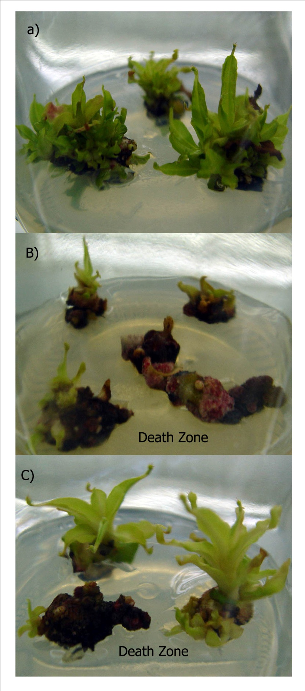

Figure 1. Effects of BAP and 2,4-D in combination and alone on shoot differentiation from excised auxillary shoots. A) 2 mg l-1 BAP B) 1 mg l-1 BAP+ 1 mg l-1 2,4-D. C) 2 mg l-1 2,4-D.

**Root Induction:** After 6 weeks of culture in BAP containing medium. Single shoots were existed and transferred to CPM with and without auxin (IBA/NAA) for root induction. Without the addition of auxin, root initiation of the plantlets did occur but shorter root lengths and a slower initiation rate was found in comparison to plantlet grown on medium with auxin. For Auxin, IBA was better than NAA for the production of plantlets with long root lengths. But to generate a higher root number, NAA was better than IBA (Figure 2B, 2D).

Interestingly, *Nepenthes* plantlets on NAA containing medium produced a relatively larger pitcher at the leaf ends (Figure 2E) compared to a pitcher from plantlets generated on IBA or hormone free medium (Figure 2E). Degree of pitcher larger is depending on NAA concentration. Size of pitcher are increase when NAA concentration increasing between 0.5 to 2 mg l-1(Figure 2A). However, NAA make Nepenthes plant lost their healthy. The larger pitcher plantlet came with reddish yellows leaves (Figure 2E). More senescent leaves on *Nepenthes* plant growing on higher NAA concentration and finally it was death on 4 mg l-1 NAA containing medium within 3 weeks.

We hypothesize that these symptoms may be caused from an insufficient amount of nitrogen to support their metabolism. Srivastava et al., 2001 reported that the presence of NAA in callus culture medium of *Cuscuta reflexa*, an angiosperm holoparasitic plant, increased the activity of enzymes in the nitrogen assimilation pathway throughout the culture period without altering their developmental profiles. These enzymes included nitrate reductase (NR), glutamine synthetase (GS), glutamate synthase (GOGAT) and glutamate dehydrogenase (GDH). Because the pitcher plant produces supplementary nitrogen from insects, if the *Nepenthes* plant require more nitrogen, it is possible that they could produce a larger pitcher to eat more insects. However, the role of NAA as a potential effector of nitrogen assimilating enzymes has not yet been investigated much in higher plants. In addition to nitrogen, there is a report that *N. insignis* used a C2-portion of the carbon skeleton of l-alanine to build up the allelochemical plumage in (Rischer *et al.,* 2002).

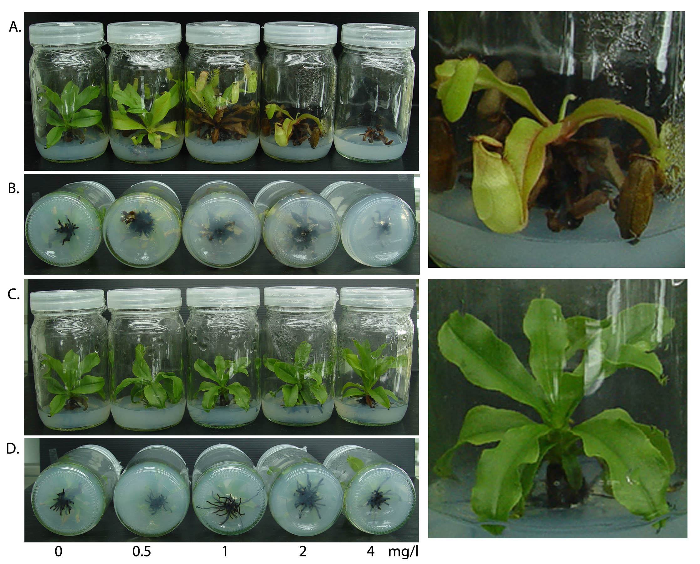

F

E

Figure 2. Effects of NAA and IBA on pitcher size and root of *in vitro* culture of *Nepenthes* hybrid on 6th weeks after sub-culture. A and B) *Nepenthes* hybrid growing on 0-4 mg l-1 NAA. C and D) *Nepenthes* hybrid growing on 0-4 mg l-1 IBA. E) Enlargement of Nepenthes plantlet growing on 2 mg l-1 NAA. F) Enlargement of Nepenthes plantlet growing on 1 mg l-1 IBA. White arrow show pitchers at leaf tip. White scale bar indicate 1 centimeter.

This increased pitcher size character of baby *Nepenthes* may increase the commercial value of glass bottle plants as a gift or decoration. One of the key advantages of bottle plants are their compact sizes which lets them grow almost anywhere with a minimal need for water and fertilizer and a minimal need for pest or disease control.

The pitcher plant is a unique and wonderful plant, which many researchers are interested in. Numerous reports about the gene expression in the pitcher were published including studies on ammonium, amino acid and peptide transporter genes (Schulze *et al.,* 1999), aspartic proteinase genes (chung *et al.,* 2002), and chitinase genes (Eilenberg *et al.,* 2006). Moreover, the proteins in pitcher fluid (Hatona & Hamada, 2008), have been shown to have differentially expressed protein at different developmental stages (Pinthong *et al.,* 2009) and plasma-membrane H+-ATPase (Chung *et al.,* 2001) have also been investigated.

This study of tissue culture of *Nepenthes* may be useful for genetic transformation of *Nepenthes* species via Agrobacterium. Besides being useful in education, this research may also be valuable for the genetic improvement of *Nepenthes* plants for trade and to produce new varieties of *Nepenthes* with new pitcher shapes and colors.

**Acknowledgements:** We gratefully acknowledge the Royal Golden Jubilee (The Thailand Research Fund) for financial supporting of this research.

**References**

An, CI., E. Fukusaki and A. Kobayashi. 2001. Plasma-membrane H+-ATPases are expressed in pitchers of the carnivorous plant *Nepenthes alata* Blanco*.* Planta, 212:547–555.

An, CI., E. Fukusaki and A. Kobayashi. 2002. Aspartic proteinases are expressed in pitchers of the carnivorous plant *Nepenthes alata* Blanco. Planta, 214: 661–667*.*

Bahadur, V., K.S. Kirad, A. Mathew and D.B. Singh*.* 2008. [Tissue culture studies in *Nepenthes khasiana*](http://www.actahort.org/books/786/786_35.htm). Acta Horticulturae (ISHS), **786**: 287–293.

Chawla, H.S., 2002. Introduction to plant biotechnology, 2nd edn. Science Publishers, Enfield

Chaveerach, A., A. Tanomtong, R. Sudmoon and T. Tanee. 2006. Genetic diversity among geographically separated populations of *Nepenthes mirabilis*. Biologia Bratislava. 61: 295-298.

CLARKE, C. 2002. A Guide to the Pitcher Plants of Peninsular Malaysia. Natural History Publications (Borneo), Kota Kinabalu.

Clarke, C. 1997. *Nepenthes* of Borneo (Kota Kinabalu, Sabah, Malaysia: Natural History Publications [Borneo])

Eilenberg, H., S. Pnini-Cohen, S. Schuster, A. Movtchan and A. Zilberstein. 2006. Isolation and characterization of chitinase genes from pitchers of the carnivorous plant *Nepenthes khasiana*. Journal of Experimental Botany. 57(11): 2775–2784.

Ellison, A.M., N. J. Gotelli, J. S. Brewer, D. L. Cochran-Stafi ra, J. M. Kneitel, T. E. Miller, A. C. Worley and R. Zamora. 2003. The evolutionary ecology of carnivorous plants; Adv. Ecol. Res. 33: 1–74.

Fossard, R. Posted on the Plant TC Listserv, Sept. 2009. Subject: *Nepenthes diatas*. (http://lists.umn.edu/cgi-bin/wa?A2=ind0901&L=PLANT-TC&T=0&F=&S=&X=1050D3258E48269160&P=2728). Also posted on: http://www.labflytrap.com/forum/viewtopic.php?f=7&t=209&start=0.

Heslop-Harrison Y. 1975. Enzyme release in carnivorous plants. Front Biol. 43:525–578.

Higashi, S., A. Nakashima, H. Ozaki, M. Abe and T. Uchiumi .1993. Analysis of feeding mechanism in a pitcher of *Nepenthes hybrida*. J Plant Res. 106:47–54.

Lutha, P.G. and S. Seeni .1994. Multiplication of endangered Indian pitcher plant (*Nepenthes khasiana*) through enhanced axillary brancing in vitro. Plant cell, Tissue and organ Culture. 38: 69-71.

McPherson, S.R. 2010. Carnivorous Plants and their Habitats. 2 volumes. Redfern Natural History Productions, Poole.

Mokkamul, P., A. Chaveerach, R. Sudmoon and T. Tanee. 2007. Species identification and sex determination of the genus *Nepenthes* (Nepenthaceae). Pak. J. Biol. Sci., 10: 561-567.

Pinthong, K., C. Arunrat, T. Tawatchai, S. Runglawan and M. Piya. 2009. Differential expressed protein in developing stages of *Nepenthes gracilis* Korth. Pitcher. Pak. J. Biol. Sci., 12: 526-529.

Rischer H., A. Hamm and G., Bringmann. 2002. *Nepenthes* *insignis* uses a C2-portion of the carbon skeleton of l-alanine acquired via its carnivorous organs, to build up the allelochemical plumbagin. Phytochemistry. 59: 603–609.

Schulze, W., W.B. Frommer and J.M. Ward. 1999. Transporters for ammonium, amino acids and peptides are expressed in pitchers of the carnivorous plant *Nepenthes*. Plant J., 17: 637-646.

Srivastava S. and U.N. Dwivedi. 2003, Modulation of key nitrogen assimilating enzymes by NAA and in vitro culture in *Cuscuta reflexa*. Plant Physiology and Biochemistry. 41: 65–71.

1.